**Скрипт и база данных**

**ER-диаграмма базы данных:**

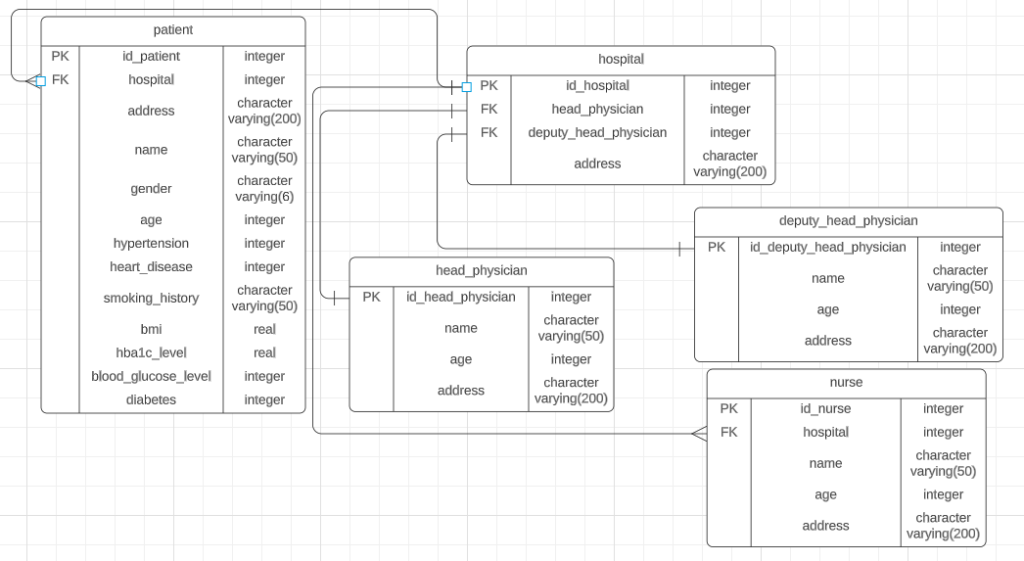  
Рисунок 1 – ER-диаграмма базы данных

В данной работе представлены связи 1-N, N:M, 1-1, описана модель больницы. Поля и названия классов пытался брать «говорящие».

1) patient – пациент и в данном классе описываются все анализы, конкретного человека и его данные.

2) head_physicial – главный врач больницы.

3) deputy_head_physicial – заместитель главного врача.

4) nurse – медперсонал.

5) hospital – больница.

**Создание базы данных:**

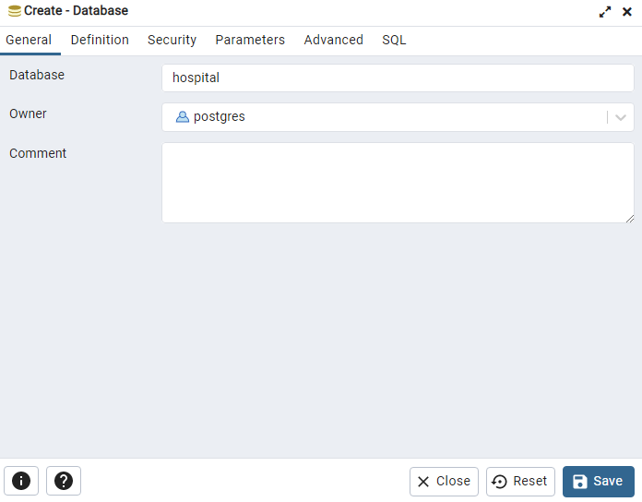

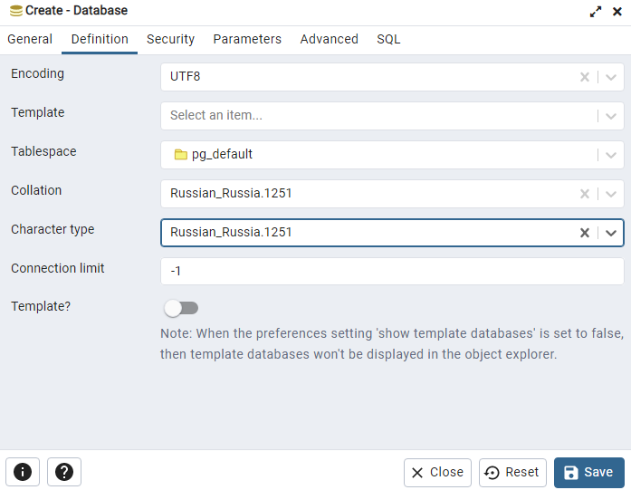

**Код создания таблиц в базе данных(Замечание: если вставлять код скорее всего выйдет ошибка из-за кавычек, поэтому двойные кавычки надо проставлять самостоятельно):**

CREATE TABLE IF NOT EXISTS hospital (

id_hospital integer NOT NULL GENERATED ALWAYS AS IDENTITY (INCREMENT 1 START 1 MINVALUE 1 MAXVALUE 1000000000 CACHE 1),

head_physician integer,

deputy_head_physician integer,

address character varying(200) COLLATE pg_catalog.”default” NOT NULL,

CONSTRAINT pkey_hospital PRIMARY KEY (id_hospital)

);

CREATE TABLE IF NOT EXISTS patient (

id_patient integer NOT NULL GENERATED ALWAYS AS IDENTITY (INCREMENT 1 START 1 MINVALUE 1 MAXVALUE 1000000000 CACHE 1),

hospital integer,

address character varying(200) COLLATE pg_catalog.”default” NOT NULL,

name character varying(50) COLLATE pg_catalog.”default” NOT NULL,

gender character varying(6) COLLATE pg_catalog.”default” NOT NULL,

age integer,

hypertension integer,

heart_disease integer,

smoking_history character varying(50) COLLATE pg_catalog.”default” NOT NULL,

bmi real,

HbA1c_level real,

blood_glucose_level integer,

diabetes integer,

CONSTRAINT pkey_patient PRIMARY KEY (id_patient)

);

CREATE TABLE IF NOT EXISTS head_physician (

id_head_physician integer NOT NULL GENERATED ALWAYS AS IDENTITY (INCREMENT 1 START 1 MINVALUE 1 MAXVALUE 1000000000 CACHE 1),

name character varying(50) COLLATE pg_catalog.”default” NOT NULL,

age integer,

address character varying(200) COLLATE pg_catalog.”default” NOT NULL,

CONSTRAINT pkey_head_physician PRIMARY KEY (id_head_physician)

);

CREATE TABLE IF NOT EXISTS deputy_head_physician (

id_deputy_head_physician integer NOT NULL GENERATED ALWAYS AS IDENTITY (INCREMENT 1 START 1 MINVALUE 1 MAXVALUE 1000000000 CACHE 1),

name character varying(50) COLLATE pg_catalog.”default” NOT NULL,

age integer,

address character varying(200) COLLATE pg_catalog.”default” NOT NULL,

CONSTRAINT pkey_deputy_head_physician PRIMARY KEY (id_deputy_head_physician)

);

CREATE TABLE IF NOT EXISTS nurse (

id_nurse integer NOT NULL GENERATED ALWAYS AS IDENTITY (INCREMENT 1 START 1 MINVALUE 1 MAXVALUE 1000000000 CACHE 1),

hospital integer,

name character varying(50) COLLATE pg_catalog.”default” NOT NULL,

age integer,

address character varying(200) COLLATE pg_catalog.”default” NOT NULL,

CONSTRAINT pkey_nurse PRIMARY KEY (id_nurse)

)

**Код для создания FK-ключей для создания связей между таблицами:**

ALTER TABLE public.hospital ADD CONSTRAINT FK_hospital_head_physician FOREIGN KEY (head_physician) REFERENCES public.head_physician(id_head_physician)

ON DELETE CASCADE

ON UPDATE CASCADE

ALTER TABLE public.hospital ADD CONSTRAINT FK_hospital_deputy_head_physician FOREIGN KEY (deputy_head_physician) REFERENCES public.deputy_head_physician (id_deputy_head_physician)

ON DELETE CASCADE

ON UPDATE CASCADE

ALTER TABLE public.nurse ADD CONSTRAINT FK_nurse_hospital FOREIGN KEY (hospital) REFERENCES public.hospital(id_hospital)

ON DELETE CASCADE

ON UPDATE CASCADE

ALTER TABLE public.patient ADD CONSTRAINT FK_patient_hospital FOREIGN KEY (hospital) REFERENCES public.hospital(id_hospital)

ON DELETE CASCADE

ON UPDATE CASCADE

**Код для заполнения данными таблиц(данный код написан на языке python в среде разработки jupyter lab):**

import csv

import random

from mimesis import Person

from mimesis import Address

from mimesis.locales import Locale

person = Person(Locale.RU)

address = Address(Locale.RU)

my_file = open("C:\head_physician.csv", "w+", newline='')

with my_file:

writer = csv.writer(my_file)

for i in range(0, 26):

newRow = []

newRow.append(i)

newRow.append(person.full_name())

newRow.append(random.randint(30, 65))

newRow.append(address.address())

writer.writerow(newRow)

my_file.close()

deputy_head_physician_file = open("C:\deputy_head_physician.csv", "w+", newline='')

with deputy_head_physician_file:

writer = csv.writer(deputy_head_physician_file)

for i in range(0, 26):

newRow = []

newRow.append(i)

newRow.append(person.full_name())

newRow.append(random.randint(26, 65))

newRow.append(address.address())

writer.writerow(newRow)

deputy_head_physician_file.close()

hospital_file = open("C:\hospital.csv", "w+", newline='')

with hospital_file:

writer = csv.writer(hospital_file)

import numpy as np

spam1 = np.random.permutation(range(1, 26))

spam2 = np.random.permutation(range(1, 26))

for i in range(0, 26):

newRow = []

newRow.append(i)

newRow.append(spam1[i-1])

newRow.append(spam2[i-1])

newRow.append(address.address())

writer.writerow(newRow)

hospital_file.close()

nurse = open("C:\ nurse.csv", "w+", newline='')

with nurse:

writer = csv.writer(nurse)

import numpy as np

for i in range(0, 101):

newRow = []

newRow.append(i)

newRow.append(random.randint(1, 25))

newRow.append(person.full_name())

newRow.append(random.randint(20, 65))

newRow.append(address.address())

writer.writerow(newRow)

nurse.close()

patient = open("C:\patient.csv", "w+", newline='')

with patient:

writer = csv.writer(patient)

import numpy as np

for i in range(0, 1000001):

newRow = []

newRow.append(i)

newRow.append(random.randint(1, 25))

newRow.append(address.address())

newRow.append(person.full_name())

newRow.append(random.choice(['М', 'Ж']))

newRow.append(random.randint(18, 85))

newRow.append(random.randint(0, 1))

newRow.append(random.randint(0, 1))

newRow.append(random.choice(['Никогда не курил(a)', 'Нет информации', 'Курил ранее', 'Курит сейчас']))

newRow.append(round(random.uniform(10, 96),2))

newRow.append(round(random.uniform(3, 10),2))

newRow.append(random.randint(80, 301))

newRow.append(random.randint(0, 1))

writer.writerow(newRow)

patient.close()

**Код для записи данных из сгенерированных файлов в базу данных:**

COPY head_physician

FROM 'C:\head_physician.csv' with delimiter ',' csv header encoding 'windows-1251';

COPY deputy_head_physician

FROM 'C:\deputy_head_physician.csv' with delimiter ',' csv header encoding 'windows-1251';

COPY hospital

FROM 'C:\hospital.csv' with delimiter ',' csv header encoding 'windows-1251';

SELECT *

FROM hospital

COPY nurse

FROM 'C:\nurse.csv' with delimiter ',' csv header encoding 'windows-1251';

SELECT *

FROM nurse

**Не с первого раза все идеально получилось поэтому использовал еще эти команды:**

TRUNCATE TABLE hospital – **очистка данных таблицы hospital**

DROP TABLE hospital – **удаление таблицы hospital**